PM Control Tower — v3.0 Command Center UI Snapshot
Captured 2026-09-19 during the v3.0 GUI verification pass (live server, seeded reference data). These are the eight new modules added in the Command Center expansion. Version 3.0.0.
Login: pmo@pmct.io (PMO Admin). All screens read the same Project/Task core as the existing Gantt, EVM and executive modules.

Boards — Kanban (drag-and-drop status lanes)
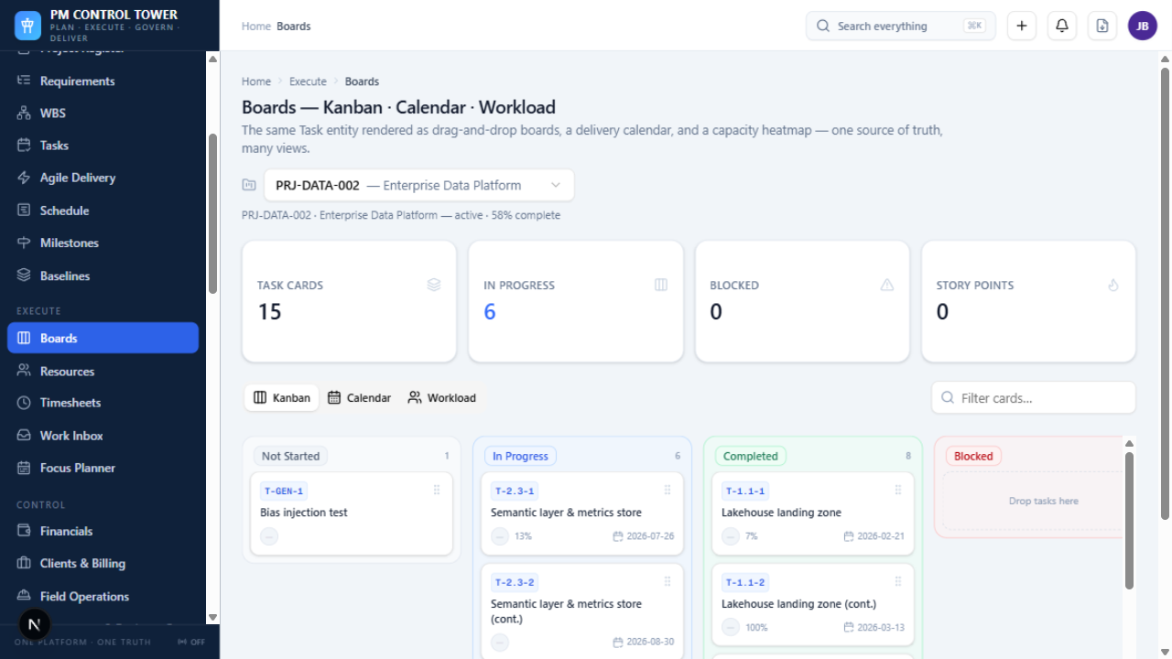

Boards — delivery Calendar
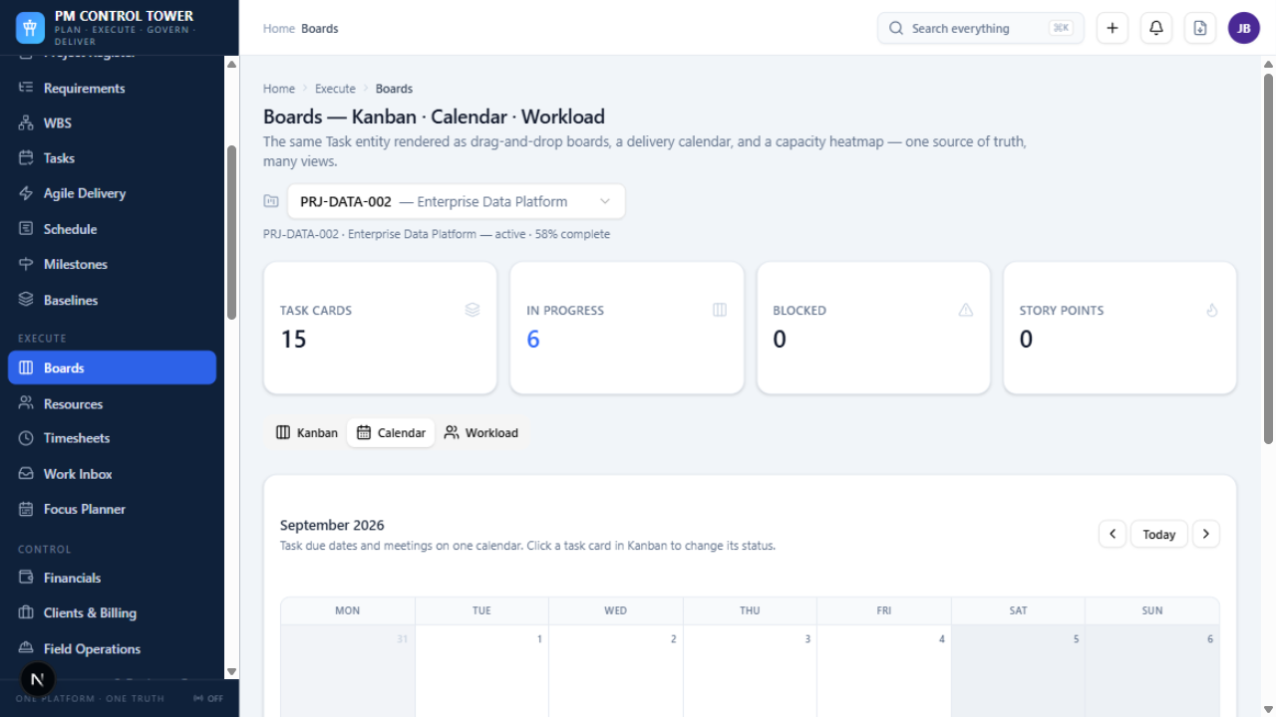

Boards — resource Workload heatmap
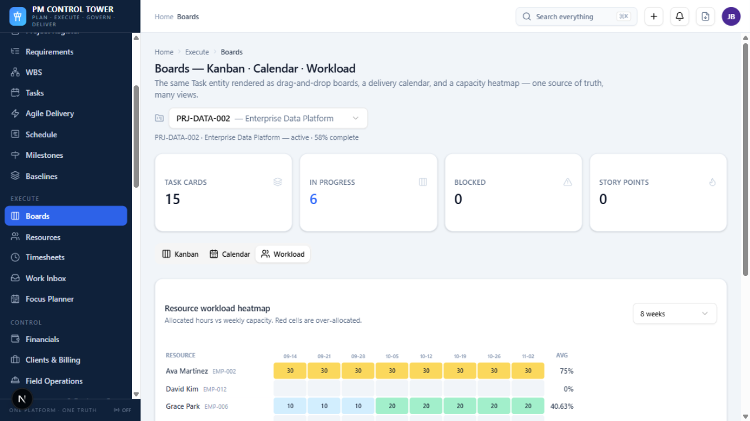

Agile Delivery — Create sprint dialog
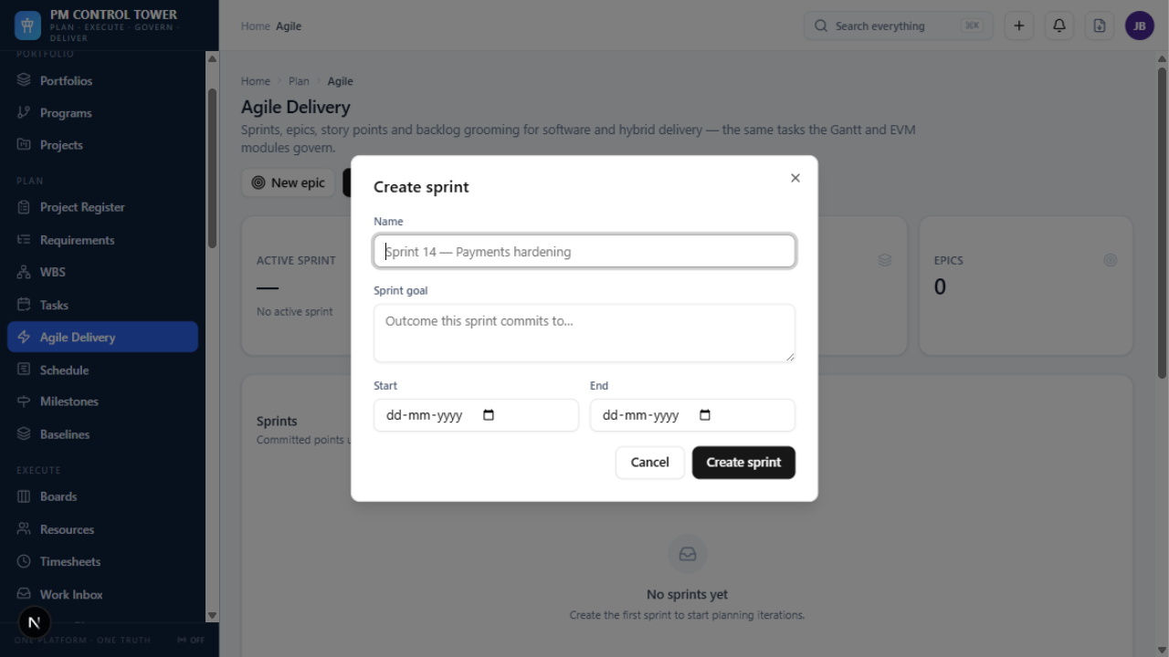

Clients & Billing — register with revenue roll-ups
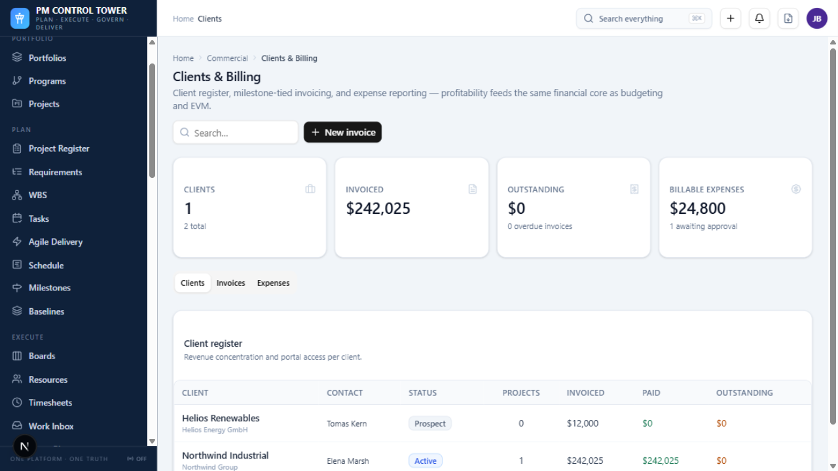

Field Operations — RFI register with aging
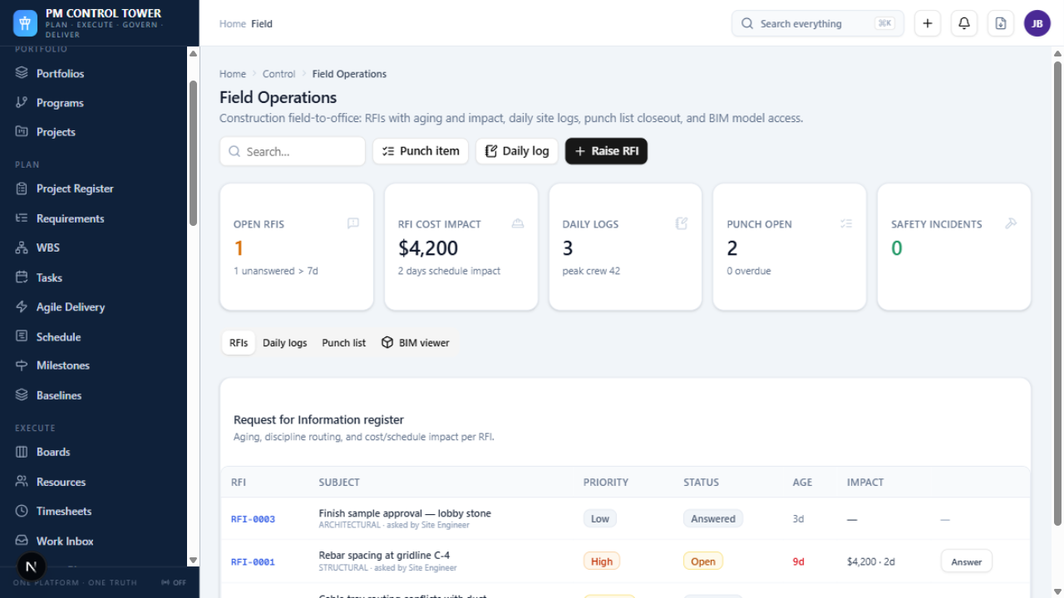

Feedback & Roadmap — voting board
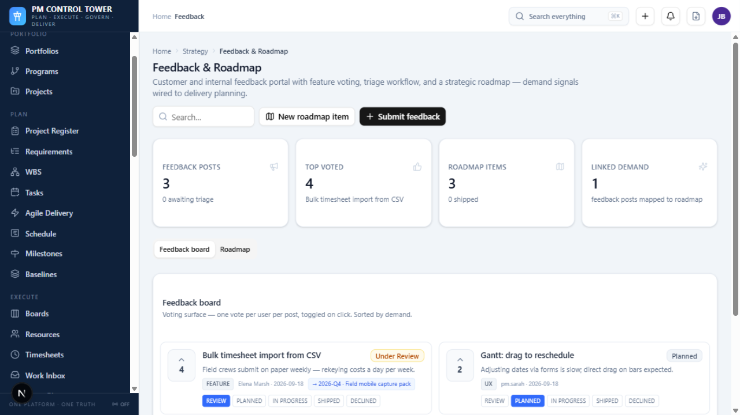

Docs & Knowledge — page index
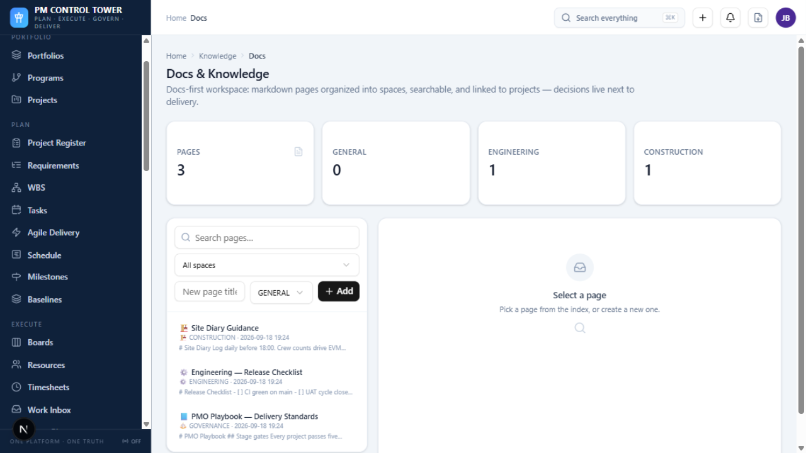

Message Boards — thread detail with reply
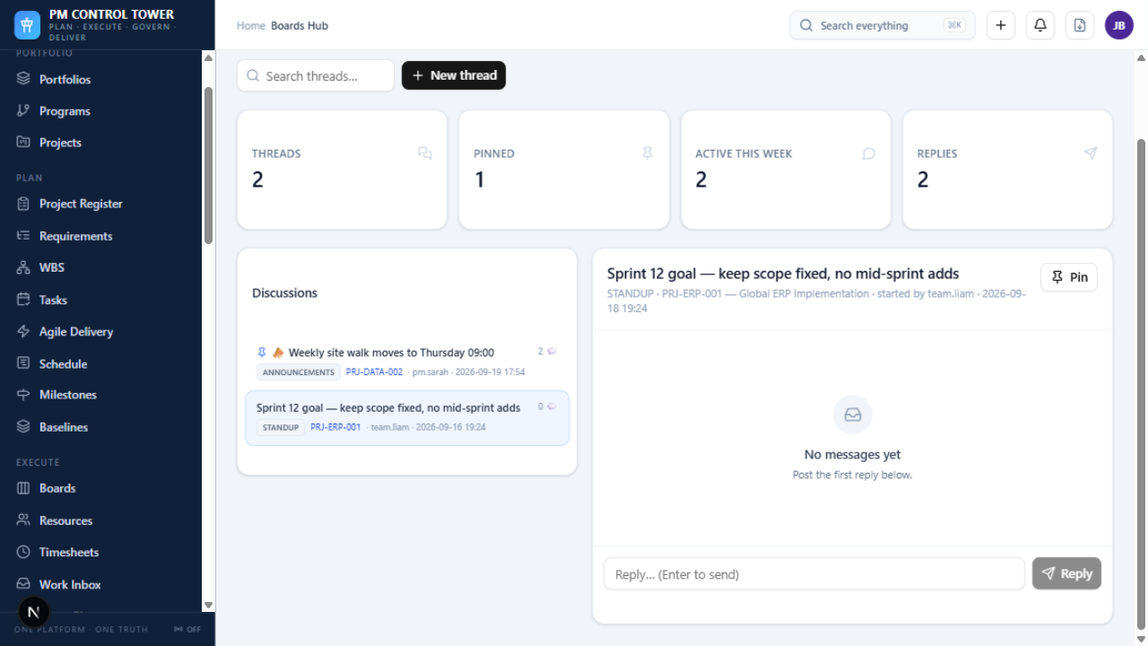

Proofing & Approvals — review rounds
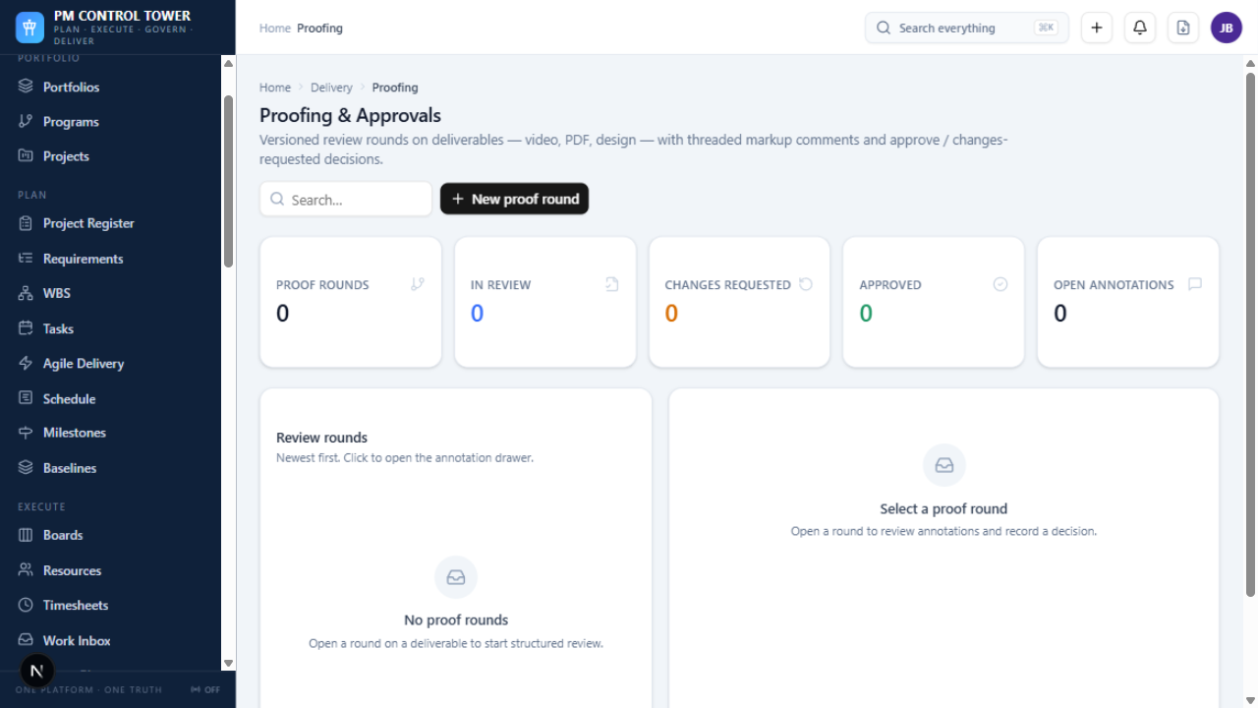

Agile Delivery — project-scoped view
